
Backwell Juniors

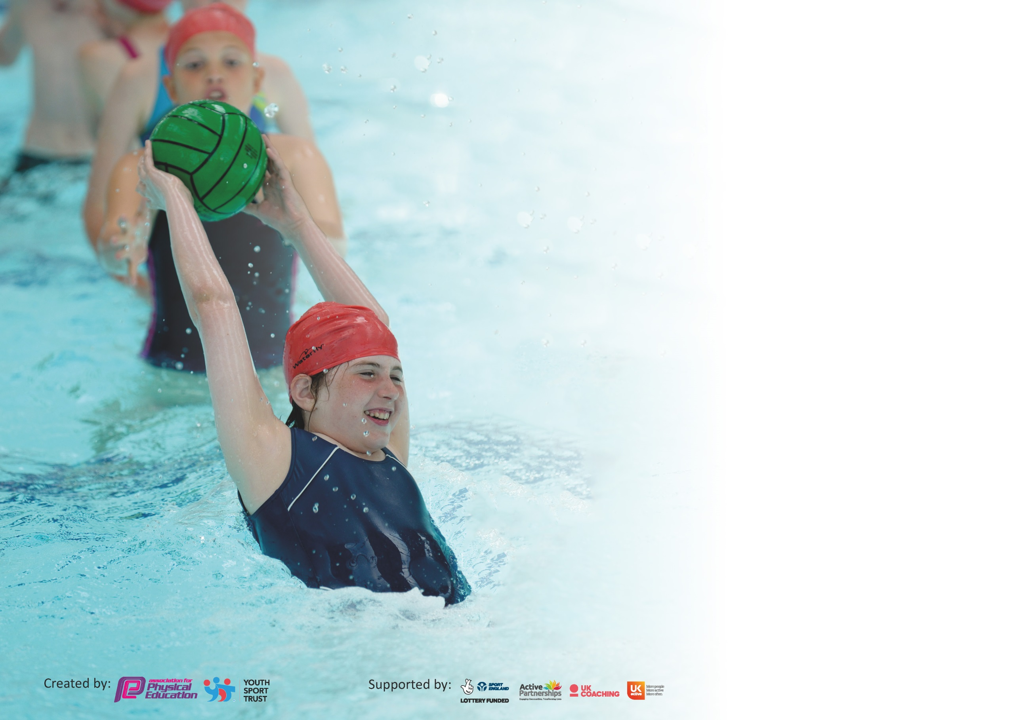

It is important that your grant is used effectively and based on school need. The Education Inspection Framework (Ofsted 2019 p64) makes clear there will be a focus on ‘whether leaders and those responsible for governors all understand their respective roles and perform these in a way that enhances the effectiveness of the school’.

Under the Quality of Education criteria (p41) inspectors consider the extent to which schools can articulate their curriculum (INTENT), construct their curriculum (IMPLEMENTATION) and demonstrate the outcomes which result (IMPACT).

To assist schools with common transferable language this template has been developed to utilise the same three headings which should make your plans easily transferable between working documents.

Schools must use the funding to make additional and sustainable improvements to the quality of Physical Education, School Sport and Physical Activity (PESSPA) they offer. This means that you should
use the Primary PE and Sport Premium to:

- Develop or add to the PESSPA activities that your school already offer
- Build capacity and capability within the school to ensure that improvements made now will benefit pupils joining the school in future years

Please visit gov.uk for the revised DfE guidance including the 5 key indicators across which schools should demonstrate an improvement. This document will help you to review your provision and to report your spend. DfE encourages schools to use this template as an effective way of meeting the reporting requirements of the Primary PE and Sport Premium.

We recommend you start by reflecting on the impact of current provision and reviewing the previous spend.

Schools are required to publish details of how they spend this funding as well as on the impact it has on pupils’ PE and sport participation and attainment by the end of the summer term or by 31st July 2020 at the latest.

We recommend regularly updating the table and publishing it on your website throughout the year. This evidences your ongoing self-evaluation of how you are using the funding to secure maximum, sustainable impact. Final copy must be posted on your website by the end of the academic year and no later than the 31st July 2020. To see an example of how to complete the table please click HERE.

Support for review and reflection - considering the 5 key indicators from DfE, what development needs are a priority for your setting and your pupils now and why? Use the space below to reflect on previous spend and key achievements and areas for development.

Key achievements to date until July 2024: | Areas for further improvement and baseline evidence of need:
1. A range of clubs taking place after school including; football clubs, netball, athletics, and gymnastics.  2. High quality teaching in every year group each week as part of curriculum teaching led by Premier Sport.  3. Active play leader at lunchtime to encourage outdoor play and team building working with all classes.  4. Highly successful sports focused weeks at each school.  5. Local Sporting events we have participated in this year include have included netball, cross country, hockey and football.  6. Passionate children which have engaged in various sporting opportunities provided.  7. High success rate of competent swimmers by the end of KS2.  8. Gold Sports Mark achieved.  9. We offer our children the opportunity to attend a wide range of after school sports clubs with financial support available for pupil premium children.  10. Walk to school initiative started. | - Ensure that all children have the opportunity to take part in competitive sports in intra or inter competitions.  - Lunchtimes to be more active with use of sports equipment – Active Play Leaders and Sports Leaders to be trained.  - Children who have not completed their 25m by the end of Y4 to be targeted in Y5 to achieve this by the end of KS2.  - Create more local links with outside clubs.  - Develop other games such as boccia/kurling/table tennis to explore other sports and games to be more inclusive.  - Opportunities for the Daily Mile.

Meeting national curriculum requirements for swimming and water safety.
What percentage of your current Year 6 cohort swim competently, confidently and proficiently over a distance of at least 25 metres?  N.B. Even though your pupils may swim in another year please report on their attainment on leaving  primary school at the end of the summer term 2020. | 100%
What percentage of your current Year 6 cohort use a range of strokes effectively [for example, front crawl, backstroke and breaststroke]? | 85%
What percentage of your current Year 6 cohort perform safe self-rescue in different water-based situations? | 85%
Schools can choose to use the Primary PE and Sport Premium to provide additional provision for swimming but this must be for activity over and above the national curriculum requirements. Have you used it in this way? | No

Action Plan and Budget Tracking
Capture your intended annual spend against the 5 key indicators. Clarify the success criteria and evidence of impact that you intend to measure to evaluate for pupils today and for the future.

Academic Year: 2023-24 | Total fund allocated: £18280 | Date Updated: July 24
Key indicator 1: The engagement of all pupils in regular physical activity – Chief Medical Officer guidelines recommend that primary school pupils undertake at least 30 minutes of physical activity a day in school |  |  |  | Percentage of total allocation:
 |  |  |  | %
Intent | Implementation |  | Impact
Your school focus should be clear what you want the pupils to know and be able to do and about  what they need to learn and to  consolidate through practice: | Make sure your actions to achieve are linked to your intentions: | Funding allocated: | Evidence of impact: what do pupils now know and what can they now do? What has changed?: | Sustainability and suggested next steps:
- Lunchtime sports activities run by Learning Partners  - After school clubs subsidised to increase participation.  - Resources purchased to support increased participation in sport.  - PE lead time to develop subject. | - Games and activities run by learning partners during lunchtimes  - Premier Sport clubs offered free for PP pupils.  - Resources purchased to enhance PE and sport offer.  - Release time and attendance at NSPEA Network and membership. | £9000  £2000  £ 1500 | - All pupils receive the offer of high quality games and activities during lunchtimes.  - Pupils have access to affordable after school provision.
Key indicator 2: The profile of PESSPA being raised across the school as a tool for whole school improvement |  |  |  | Percentage of total allocation:
 |  |  |  | %
Intent | Implementation |  | Impact | Mainly funded by PTA
Your school focus should be clear what you want the pupils to know and be able to do and about  what they need to learn and to  consolidate through practice: | Make sure your actions to achieve are linked to your intentions: | Funding allocated: | Evidence of impact: what do pupils now know and what can they now do? What has changed?: | Sustainability and suggested next steps:
- Deliver a sports week to offer pupils a wide range of alternative sporting activities | - Sports week delivered offering pupils sports ranging from climbing, zorbing and forest schools | £2000 – part PTA funded | Children will have a better understanding of healthy living.  Pupils exposed to a wide range of sports and fun activities led by many professional coaches.

Key indicator 3: Increased confidence, knowledge and skills of all staff in teaching PE and sport |  |  |  | Percentage of total allocation:
 |  |  |  | %
Intent | Implementation |  | Impact
Your school focus should be clear | Make sure your actions to | Funding | Evidence of impact: what do | Sustainability and suggested
what you want the pupils to know | achieve are linked to your | allocated: | pupils now know and what | next steps:
and be able to do and about | intentions: |  | can they now do? What has
what they need to learn and to |  |  | changed?:
consolidate through practice:
- Staff CPD through observing and involvement in high quality PE teaching by Premier Sport | - Increased confidence, knowledge and skills to teach PE and sport | As above | Increased confidence of staff delivering PE across the school
Key indicator 4: Broader experience of a range of sports and activities offered to all pupils |  |  |  | Percentage of total allocation:
 |  |  |  | %
Intent | Implementation |  | Impact
Your school focus should be clear | Make sure your actions to | Funding | Evidence of impact: what do | Sustainability and suggested
what you want the pupils to know | achieve are linked to your | allocated: | pupils now know and what | next steps:
and be able to do and about | intentions: |  | can they now do? What has
what they need to learn and to |  |  | changed?:
consolidate through practice:
- To broaden the range of school clubs including inclusive sports to encourage more children to participate in sport including children with physical difficulties.  - Deliver a sports week to offer pupils a wide range of alternative sporting activities | - Range of clubs run after school by both school staff and external sport specific coaches.  - Sports week delivered offering pupils sports ranging from climbing, zorbing and forest schools | £  £3000 – part PTA funded | Children will have a better understanding of healthy living.  Pupils exposed to a wide range of sports and fun activities led by many professional coaches.

Key indicator 5: Increased participation in competitive sport |  |  |  | Percentage of total allocation:
 |  |  |  | %
Intent | Implementation |  | Impact | 10
Your school focus should be clear | Make sure your actions to | Funding | Evidence of impact: what do | Sustainability and suggested
what you want the pupils to know | achieve are linked to your | allocated: | pupils now know and what | next steps:
and be able to do and about | intentions: |  | can they now do? What has
what they need to learn and to |  |  | changed?:
consolidate through practice:
- Providing Supply teachers to release staff to attend competitions so that pupils can attend more events and staff benefit from experience of monitoring and refereeing.  - Provide Coaches to take children to sports events | Increased attendance at football and sports festivals to increase participation. | £1500 | Increased level of participation in competitive sports.

Signed off by
Head Teacher: | N. Webster
Date: | July 24
Subject Leader: | N. Webster
Date: | July 24
Governor:
Date:

