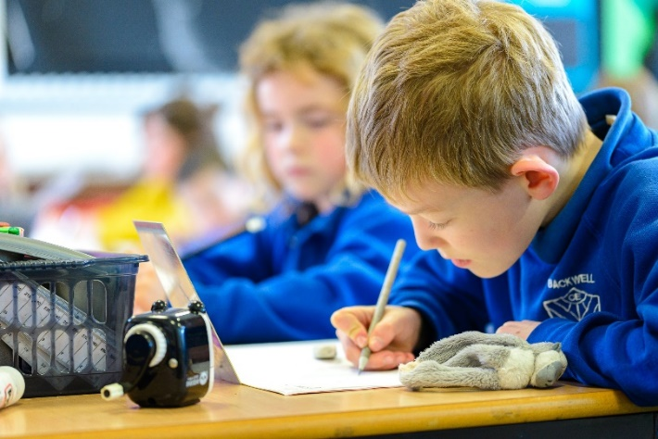

English Writing at Backwell Federation

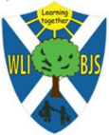
At West Leigh Infants and Backwell Juniors we believe that the key to unlocking pupils' full learning potential is to develop their knowledge of English skills. Through our engaging curriculum, we entwine reading and writing together as one to inspire and our engage learners. Exposure to high-quality texts and access to vocabulary-rich learning opportunities and environments help to promote a love of language as well as opening them up to worlds of wonder, curiosity and joy. In the early years of reading and writing, a strong emphasis is place on the systematic teaching of phonics to give all children a strong foundation to build upon. Everyone at Backwell Federation is viewed as a writer and our priority is to create writers who have a passion for words and instill a love of reading and writing.

Our Curriculum

The Early Years Foundation Stage, which sets standards for the learning, development and care of children from birth to five years old, is followed by Reception. The National Curriculum is followed in Key Stage One and Two. The National Curriculum provides a clear progression in knowledge and the small, incremental steps within year groups helps to embed skills and secure learning. Through the use of small step learning and chunking in our writing lessons, children are able to understand how their learning is set into a broader context.

High Quality Texts
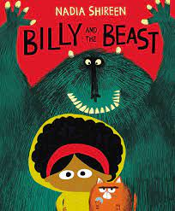
High quality texts are at the core of our teaching for writing. Texts are carefully chosen to capture children’s imagination, inspire them and create an engaging stimulus for writing. These texts are starting points for a unit of writing and can range from a few weeks up to one short term. Our non-fiction writing is often developed from a wider context across the curriculum but the focus is always high quality written outcomes.
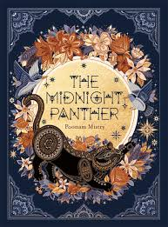
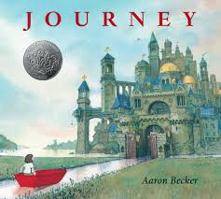
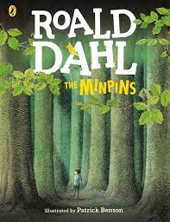
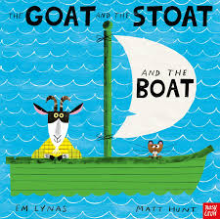

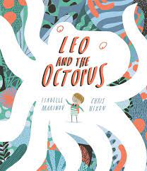
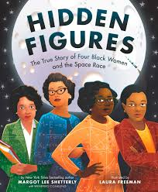
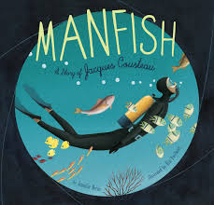
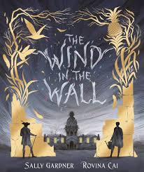

 | Term 1 | Term 2 | Term 3 | Term 4 | Term 5 | Term 6
Reception | A Little Bit Brave by Nicola Kinnear  The Big Book of Families by Mary Hoffman  The Colour Monster by Anna Llenas | The Three Little Pigs by Axel Schefflers  Stickman by Julia Donaldson | The Goat and the Stoat and the Boat by Em Lynas  When Granny went to Market by Stella Blackstone | Perfectly Norman by Tom Percival  Surprising Sharks by Nicola Davies | Bun on the Run by Smitri Halls  Jack and the Beanstalk by Ara Alperin | Martha Maps it Out by Leigh Hodgkinson  The Naughty Bus by Jan and Jerry Oke
KS1 Cycle A | The Odd Egg by Emily Gravett  Journey by Aaron Becker | Toys in Space by Mini Grey | Night Flight by Katie Cottle | The Dragon Machine by Helen Ward | Anthony Browne  - Willy the Dreamer  - Gorilla  - The Tunnel  - Silly Billy | The Magic Finger by Roald Dahl
KS1 Cycle B | Stanley’s Stick by John Hegley  Billy and the Beast by Nadia Shireen | Where the Wild Things Are by Maurice Sendak | The Last Stop on Market Street by Matt de la Peña | TBC | Goldilocks alternative texts:  - Goldilocks and the Three Bears by Lauren Child  - Me and You by Anthony Browne  - Goldilocks and Just the Bear by Leigh Hodgkinson | Leo and the Octopus by Isabelle Marinov
Year 3 | The Minpins by Roald Dahl | The Barnabus Project by Devin Fan and Terry Fan | Our Tower by Joseph Coelho | The Miraculous Journey of Edward Tulane by Kate DiCamillo | The Midnight Panther by Poonam Mistry | The Big Book of Blooms by Elisa Biondi and Yuval Zommer
Year 4 | The Secret of Black Rock by Joe Todd-Stanton | Until I met Dudley by Roger McGough | Little House by Katya Balen | Just a Dream by Chris Van Allsburg | Manfish: A Story of Jacques Cousteau by Jennifer Berne | The Wild Robot by Peter Brown
Year 5 | There’s a Boy in the Girl’s Bathroom by Louis Sachar | The Whale by Ethan Murrow | Curiosity: The Story of the Mars Rover by Markus Motum | Hidden Figures by Margot Lee Shetterly | The Highwayman by Alfred Noyes | Romeo and Juliet
Year 6 | The Dam by David Almond | Letters from the Lighthouse by Emma Carroll | Floodland by Marcus Sedgwick | Ossiri and the Bala Mengro by Katharine Quarmby | The Silence Seeker by Ben Morley | The Wind in the Wall by Sally Gardner

The Writing Sequence – Reception

The Writing Sequence – KS1

The Writing Sequence – KS2

Immerse | - Exploration of high quality text or other stimulus.  - Use of drama to identify with the text and/or characters.  - Use of videos or real life situations to engage and inspire.
Analyse | - Exploring the text and identifying the language features of focus genre.
SPaG | - Direct teaching of SPaG from National Curriculum and appropriate for chosen genre.  - Retrieval of previously taught skills.
Sentence stacking | - Lessons broken up into small manageable chunks with high quality modelling of a SPaG focus or sentence construction.  - Following an initiate (gathering ideas and vocabulary), model (teachers modelling a sentence of sentences) and enable phase (children to use the model to create their own high-quality sentences).
Short burst writes | - Interspaced with sentence staking to allow opportunity to explore skills taught through SPaG and sentence stacking sessions.
Planning | - Linked to independent version of writing focus.  - Planning could be shared, through a story map or flow charts.
Write | - Initial independent draft based on focus writing genre.
Edit and proof | - Teacher taught review process which could include editing slips for re-write.
Publish | - Could be a perfect paragraph.

High Quality Modelling and Sentence Stacking

Modelling high-quality examples of writing is vital to ensuring that we are demonstrating best practice for writing. During modelled writing, the teacher shows the children how to do something in writing and will help the children make progress. Modelling at Backwell Federation is always presented ‘live in the moment’ with a pen in hand and on flipchart paper. Teachers give a running commentary of their thought process as a writer. Teachers always have a clear direction for the writing and model appropriate spelling, punctuation, grammar and presentation.

.

Feedback and Formative Assessment – KS1 and KS2

At Backwell Federation success criteria and rubrics are used as an assessment tool. When teaching a specific SPaG skill, rubrics are used and for longer pieces of writing, for example an end of unit piece, success criteria are used.

Throughout a unit of writing, specific SPaG skills are learnt so are added to the success criteria for the final writing outcome. Additions to the SPaG elements of the success criteria are linked to the learning intention or National Curriculum objectives, ensuring a clear assessment focus in order to avoid cognitive overload. At the end of the piece of writing, children assess their work against the success criteria. The success criteria provide three levels of challenge with yellow rows for challenge one (everyone must do); yellow and green rows for challenge two; and yellow green and blue rows for challenge three. These assessments are also used by the teacher to spot and address common misconceptions.

Year 1 Rubrics Example Year Two Success Criteria Example


