

Maths at Backwell Federation

At West Leigh Infants and Backwell Juniors we believe that maths is an essential life skill in which we passionately believe all children can be successful. Building confidence in maths skills is crucial to preventing anyone from feeling like they ‘can’t do maths.’ In our maths lessons, our aim is not just to teach the acquisition of numerical facts and methods but also to teach a deeper understanding of the meaning and reasoning behind the ‘whys’ of maths. In this way, children can make links, spot patterns and build upon their prior knowledge to explore new and challenging concepts, secure learning and make real progress. We use explicit teaching and a small steps approach to support our children in gaining a deeper understanding of key mathematical concepts at a pace that is right for them. We want our children to experience the creativity and connectivity of maths, both within itself and the wider areas of life.

Our Curriculum
EYFS
Maths is taught through Mastering Number which is a DfE programme focusing on improving fluency and automaticity within the following strands.
- Counting, cardinality, ordinality
- Subitising
- Composition of number, numbers within numbers
- Comparison
- Number facts and arithmetic
The EYFS teachers also plan additional shape, pattern and measure activities for breadth of understanding.

KS1 / KS2
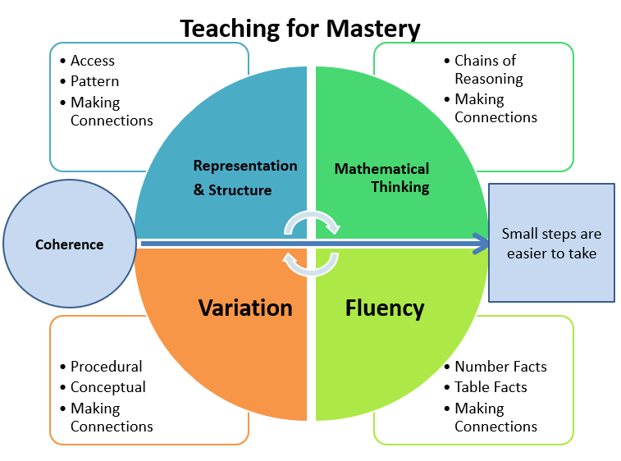
To shape our learning, we use the White Rose Maths scheme (Y1 – Y6) which has been created by a group of teachers and mathematicians dedicated to developing maths education for everyone and meets the requirements of the National Curriculum. All KS1 and KS2 year groups cover the key areas of mathematics: place value, four operations, measures, fractions, geometry and statistics at an age-appropriate level. The White Rose scheme has been developed using a ‘teaching for mastery’ approach and focuses on developing a deep understanding of concepts before moving on to new material. Each area is revisited and extended in the subsequent year, resulting in a spiral curriculum. The ‘Five Big Ideas’ identified by NCETM (and underpinning the mastery approach) are key to our teaching:

Usual structure of a maths lesson
KS1

KS2

Start of the lesson | - Share Learning Intention with the class.  - Share and discuss key vocabulary.
Retrieval / oracy (suggested activities) | - Flashback,  - Retrieval starter,  - Talk for 10 (T410),  - Fluency activity,  - Classroom Secrets – Rapid Arithmetic Resources,  - Games – Top Marks has some good ones,  - Whole class gap task (if misconception identified in a previous lesson)
Explicit Teaching | - Learning chunked into small steps to promote success.  - Teacher modelling using manipulatives and written calculations (as appropriate).  - Use of stem sentences and deliberate choice of representations (not all WR slides will suit).  - Messy thinking (metacognitive talk)  - Addressing misconceptions.
I do, we do, you do | - Worked examples and more messy thinking – I do  - Backward fading, where children do the messy thinking as a class – we do  - Moving towards easy to achieve independent practice – you do (CFU / hinge question)
Explicit teaching | - Repeat above for subsequent learning chunks as needed – see above
I do, we do, you do | - See above
Checking for understanding (CFU) | Continuous practise throughout the lesson. Methods could include  - Use of Show Me boards  - Show me on your fingers  - Talk Partners and Think, Pair, Share  - Cold calling / kind calling out  - Vote  - Hinge to guide move into independent practise or further teacher led input
Independent / guided work | - Independent practice carefully planned to maximise success of all children.  - No ‘new’ learning introduced without adult input (teacher or Learning Partner).  - Scaffolds used to enable all children to access tasks.  - Effective use of Learning Partners.  - Promote ‘keep up’ not ‘catch up’.  - Provide extension activities as needed.
Mid-point mark | - Address common misconceptions either through children marking their own work (KS2) or through the teacher providing individual feedback (KS1).  - Redirect children to become more independent or join adult group.
Independent / guided work | See above
End-point mark | - Children self-assess own learning using colours and ICT (KS2) and Goldilocks (KS1).  - Address common misconceptions either through children marking their own work (KS2) or through the teacher providing individual feedback (KS1).  - Inform next steps.
Exit ticket | - Review activity to check for understanding.
Teachers are encouraged to decide whether the above lesson sequence is appropriate for the specific small step being taught and / or their class on a lesson-by-lesson basis.

High Quality Modelling

Modelling high-quality examples of methods and concepts is vital to ensuring that we are demonstrating best practice for maths learning. During modelled examples, the teacher shows the children how to do something using manipulatives, equipment, various representations and calculations as appropriate to the learning to help the children make progress. Each representation and method from the options presented by White Rose is carefully selected by the teacher to meet the needs of their class. Not all resources provided by the scheme will be appropriate / needed – this selection process is also important to support appropriate pace in children’s learning. Misconceptions are also anticipated and addressed at this stage.

Modelling at Backwell Federation is always presented ‘live in the moment’ either on whiteboards, flipcharts or practically. Teachers give a running commentary of their thought process as a mathematician. Marvelous mistakes are used deliberately to encourage the children to challenge the teacher’s thinking and thereby deepen their own understanding.

The ‘I do, we do, you do’ approach is a key part of learning, with the ‘we do’ being an important time to stretch learning through discussion, whilst the ‘you do’ is where children demonstrate their understanding of the concept / method with a comfortable to achieve example. Checking for understanding is embedded throughout the lesson (through the methods shown above) and is used by the teacher to guide children either into independent work, adult led support or to redirect the entire lesson in response to the needs of the class.

Feedback and Assessment – KS1 and KS2

Continuous feedback is given throughout every lesson and work is marked in accordance with the Federation Marking Policy.

Learning is assessed at the end of each unit through the use of retrieval questions and practice using the White Rose end of unit assessment tools. NFER Spring and end of year assessments are used Y2-Y5 for twice yearly formal assessments. All assessments are used to inform next steps, retrieval practice and identify areas for over-learning.

Times Tables

Learning of times tables begins in KS1 with an initial introduction into the concept of multiplication and focus on the 2, 5 and 10 times tables in Y2. Y3 reinforce previous learning and focus on learning the 3, 4 and 8 times tables. Y4 reinforce previous learning and cover the remaining times table facts up to the 12 times table. This is taught explicitly as part of the White Rose curriculum and is supported by additional daily times table fact practise. All children will take part in the statutory multiplication times table check (MTC) at the end of Year 4. Times table knowledge continues to be a focus in Y5 and Y6 through the additional daily times table fact practise. All KS2 children undertake a times table test every week, progressing through each table 3 times with increasing difficulty (including linked division facts). Additional challenges include fractions and percentages of amounts.

