Maths progression EYFS-Y6
(Examples indicate end of year expectations)
Topic | EYFS | Year 1 | Year 2 | Year 3 | Year 4 | Year 5 | Year 6
Place Value | Count reliably with numbers from 1 to 20, place them in order and say which number is one more or one less than a given number. | Count to 100, forwards and backwards, beginning with 0 or 1, or from any given number.  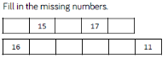  Count, read and write numbers to 100 in numerals and words.  Given a number, identify one more or one less.  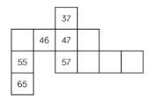  Identify and represent numbers using objects and pictorial representations including the number line, and use the language of: equal to, more than, less than (fewer), most, least.  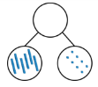  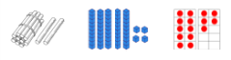    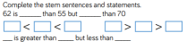  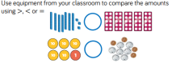 | Read and write numbers to at least 100 in numerals and in words.  Recognise the place value of each digit in a two digit number (tens, ones).  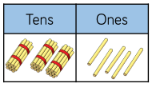  Identify, represent and estimate numbers using different representations including the number line.  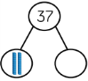  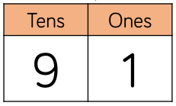  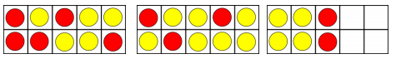  Compare and order numbers from 0 up to 100; use <, > and = signs.  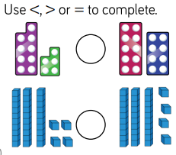  Use place value and number facts to solve problems.  Count in steps of 2, 3 and 5 from 0, and in tens from any number, forward and backward.  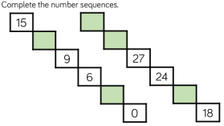 | 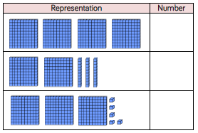  Identify, represent and estimate numbers using different representations.  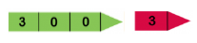  300 + 3 = 303  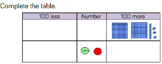  Find 10 or 100 more or less than a given number.  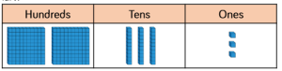  Recognise the place value of each digit in a three-digit number (hundreds, tens, ones).  Compare and order numbers up to 1000 (using < > = signs and accompanying language).  Read and write numbers up to 1000 in numerals and in words.  Solve number problems and practical problems involving these ideas.  Count from 0 in multiples of 4, 8, 50 and 100. | Count in multiples of 6, 7, 9, 25 and 1000.  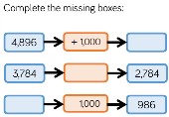  Find 1000 more or less than a given number.  Recognise the place value of each digit in a four digit number (thousands, hundreds, tens and ones).  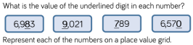  Order and compare numbers beyond 1000.  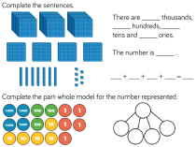  Identify, represent and estimate numbers using different representations.  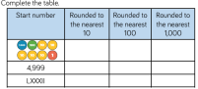  Round any number to the nearest 10, 100 or 1000.  Solve number and practical problems that involve all of the above and with increasingly large positive numbers.  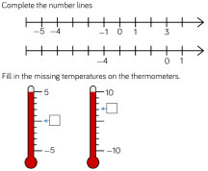  Count backwards through zero to include negative numbers. | Read, write, order and compare numbers to at least  1,000,000 and determine the value of each digit.  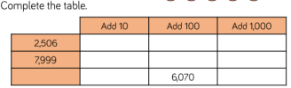  Count forwards or backwards in steps of powers of 10 for any given number up to 1,000,000.  Round any number up to 1,000,000 to the nearest 10, 100,  1,000, 10,000 and 100,000.  Solve number problems and practical problems that involve all of the above.  Read Roman numerals to 1,000  (M) and recognise years written in Roman numerals.  Interpret negative numbers in context, count forwards and backwards with positive and negative whole numbers including through zero. | Read, write, order and compare (using < > = signs) numbers up to 10,000,000 and determine the value of each digit.  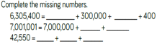  Round any whole number to a required degree of accuracy.  Use negative numbers in context, and calculate intervals across zero.  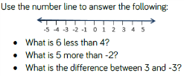  Solve number and practical problems that involve all of the above.
Addition | Using quantities and objects, they add and subtract two single-digit numbers and count on or back to find the answer.    e.g. 7 add 3 =  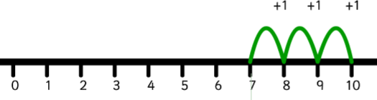  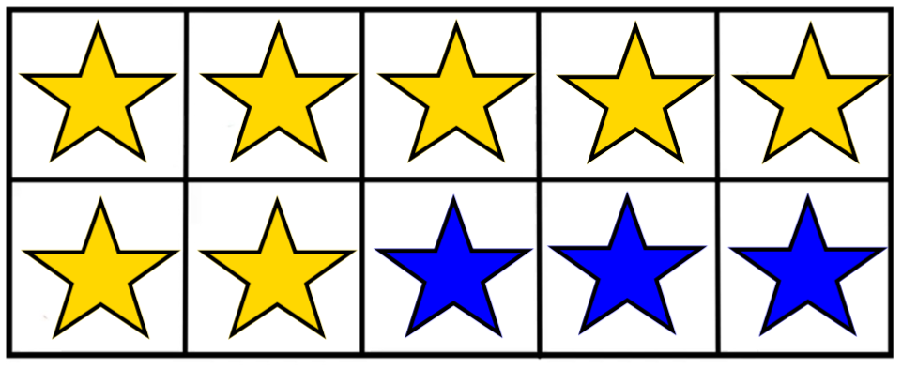 | Represent and use number bonds and related subtraction facts within 10 then 20.  Read, write and interpret mathematical statements  involving addition (+), subtraction (-) and equals (=)  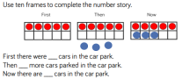  Add and subtract one digit numbers to 10, including zero. Add and subtract one digit and two digit numbers to 20, including zero.  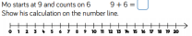  Add by making 10 e.g. 9 + 3 =  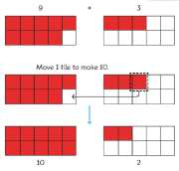  Add by adding ones:  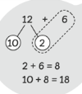  Solve one step problems that involve addition and  subtraction, using concrete objects and pictorial  representations, and missing number problems such as  7= ꙱ - 9. | Recall and use addition and subtraction facts to 20 fluently, and derive and use related facts up to 100.  Add and subtract numbers using concrete objects, pictorial representations, and mentally, including: a two-digit number and ones; a two-digit number and tens; two two-digit numbers; adding three one-digit numbers.  Using Base 10 representations to add two 2-digit numbers e.g.  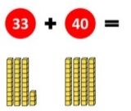  Adding two 2-digit numbers using columnar addition e.g.  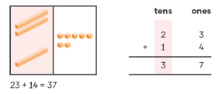  Show that the addition of two numbers can be done in any order (commutative) and subtraction of one number from another cannot.  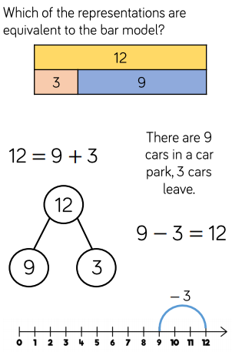  Solve problems with addition and subtraction: using concrete objects and pictorial representations, including those involving numbers, quantities and measures; applying their increasing knowledge of mental and written methods.  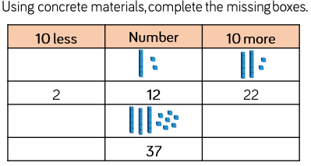  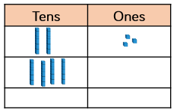  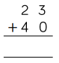  Recognise and use the inverse relationship between addition and subtraction and use this to check calculations and solve missing number problems. | Add numbers mentally, including: a three-digit number and ones; a three-digit number and tens; a three digit number and hundreds.  Add numbers with up to three digits, using formal written methods of columnar addition.  24+15=39  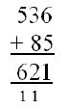  Formal written method with regrouping.  Estimate the answer to a calculation and use inverse operations to check answers.  Solve problems, including missing number problems, using number facts, place value, and more complex addition. | Add numbers with up to 4 digits using the formal written methods of columnar addition where appropriate.  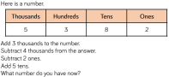  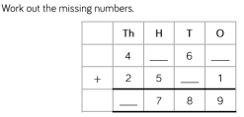  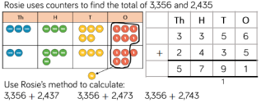  Estimate and use inverse operations to check answers to a calculation.  Solve addition two step problems in contexts, deciding which operations and methods to use and why. | Add numbers mentally with increasingly large numbers.  Add whole numbers with more than 4 digits, including using formal written methods (columnar addition).  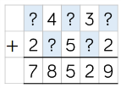  Use rounding to check answers to calculations and determine, in the context of a problem, levels of accuracy.  Solve addition multi step problems in contexts, deciding which operations and methods to use and why.  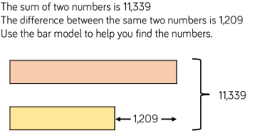  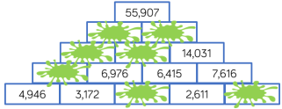 | Solve addition multi step problems in contexts, deciding which operations and methods to use and why.  Missing digits:  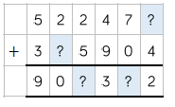  Uneven decimal places:  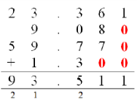  Bar model possibilities:  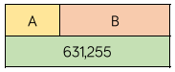  Perform mental calculations, including with mixed operations and large numbers.  Use their knowledge of the order of operations to carry out calculations involving the four operations.  Solve problems involving addition, subtraction, multiplication and division.  Use estimation to check answers to calculations and determine in the context of a problem, an appropriate degree of accuracy.
Subtraction | Using quantities and objects, they add and subtract two single-digit numbers and count on or back to find the answer.  e.g. 6 subtract 2  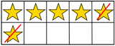  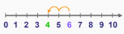 |  | Add and subtract numbers using concrete objects, pictorial representations, and mentally, including: a two-digit number and ones; a two-digit number and tens; two two-digit numbers; adding three one-digit numbers.  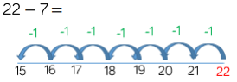  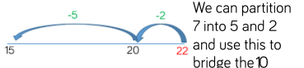  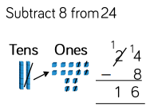  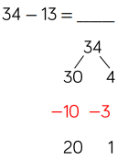 | Subtract numbers mentally, including: a three-digit number and ones; a three-digit number and tens; a three digit number and hundreds.  Subtract numbers with up to three digits, using formal written methods of columnar subtraction.  553 – 32 = 521  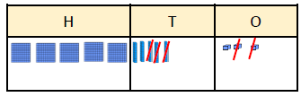  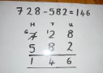  Estimate the answer to a calculation and use inverse operations to check answers.  Solve problems, including missing number problems, using number facts, place value, and more complex subtraction. | Subtract numbers with up to 4 digits using the formal written methods of columnar subtraction where appropriate.  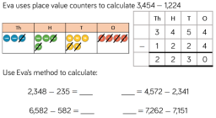  6531 – 2385= 4146  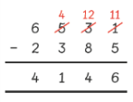  Estimate and use inverse operations to check answers to a calculation.  Solve subtraction two step problems in contexts, deciding which operations and methods to use and why. | Subtract numbers mentally with increasingly large numbers.  Subtract whole numbers with more than 4 digits, including using formal written methods (columnar subtraction).  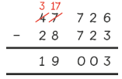  Use rounding to check answers to calculations and determine, in the context of a problem, levels of accuracy.  Solve subtraction multi step problems in contexts, deciding which operations and methods to use and why. | Solve subtraction multi step problems in contexts, deciding which operations and methods to use and why.  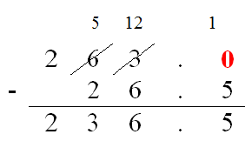  Perform mental calculations, including with mixed operations and large numbers.  Use their knowledge of the order of operations to carry out calculations involving the four operations.  Solve problems involving addition, subtraction, multiplication and division.  Use estimation to check answers to calculations and determine in the context of a problem, an appropriate degree of accuracy.
Multiplication | Solve problems, including doubling, halving and sharing  Double 5    Non-statutory  Count in 2s, 5s and 10s  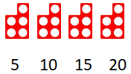 | Count in multiples of twos, fives and tens.  Solve one step problems involving multiplication and division, by calculating the answer using concrete objects, pictorial representations and arrays with the support of the teacher:  i.e. lots of 3 =  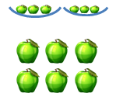  There are two bowls with three apples in each. How many apples are there altogether? | Recall and use multiplication facts for the 2, 5 and 10 times tables, including recognising odd and even numbers.  Calculate mathematical statements for multiplication within the multiplication tables and write them using the multiplication (x) and equals (=) sign.  Solve problems involving multiplication using materials, arrays, repeated addition, mental methods and multiplication facts, including problems in contexts.  Show that the multiplication of two numbers can be done in any order (commutative) and division of one number by another cannot.  5x3=  3x5= | Use the multiplication tables they know to write and solve multiplication calculations including for 2-digit numbers times 1-digit numbers, using mental and progressing to formal written methods.  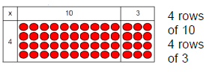  Partitioning to multiply:  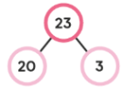  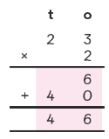  Solve problems, including missing number problems, involving multiplication and division, including positive integer scaling problems and correspondence problems in which n objects are connected to m objectives. | Recall and use multiplication and division facts for multiplication tables up to 12 × 12.  Count in multiples of 6, 7, 9, 25 and 1000.  Use place value, known and derived facts to multiply mentally, including multiplying by 0 and 1; multiplying together three numbers.  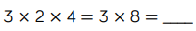  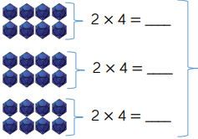  Solve problems involving multiplying and adding, including using the distributive law to multiply two digit numbers by one digit, integer scaling problems and harder correspondence problems such as n objects are connected to m objects.  8x26=  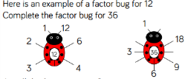  Recognise and use factor pairs and commutativity in mental calculations.  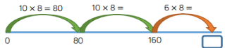  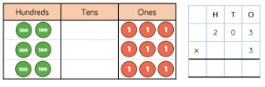  Multiply two digit and three digit numbers by a one digit number using formal written layout.  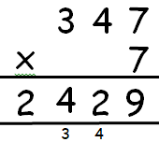  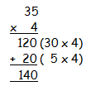 | Identify multiples and factors, including finding all factor pairs of a number, and common factors of 2 numbers.  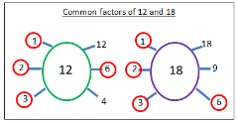  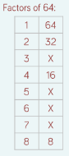  Know and use the vocabulary of prime numbers, prime factors and composite (non-prime) numbers.  Establish whether a number up to 100 is a prime and recall prime numbers up to 19.  Multiply numbers up to 4 digits by a one or two digit number using a formal written method, including long multiplication for two digit numbers.  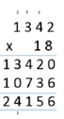  Multiply numbers mentally, drawing upon known facts.  Multiply whole numbers and those involving decimals by 10, 100 and 1,000.  Recognise and use square numbers and cube numbers, and the notation for squared (²) and cubed (³).  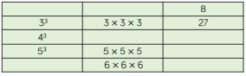  Solve problems involving multiplication including using their knowledge of factors and multiples, squares and cubes.  Solve problems involving addition, subtraction, multiplication and division and a combination of these, including understanding the meaning of the equals sign. | Multiply multi-digit number up to 4 digits by a 2-digit number using the formal written method of long multiplication.  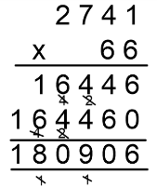  Perform mental calculations, including with mixed operations and large numbers.  Identify common factors, common multiples and prime numbers.  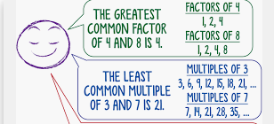  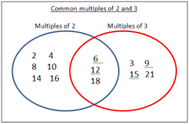  Use squared and cubed numbers.  6² = 36 (6x6=36)  6³ = 216 (6x6x6=216)  Use their knowledge of the order of operations to carry out calculations involving the four operations.  Solve problems involving addition, subtraction, multiplication and division.  Use estimation to check answers to calculations and determine in the context of a problem, an appropriate degree of accuracy.
Division | Solve problems, including doubling, halving and sharing    Half of 6 | Solve one step problems involving division, by calculating the answer using concrete objects, pictorial representations and arrays with the support of the teacher.  Sharing:  How many apples are in each bowl if I share 6 apples between three bowls?  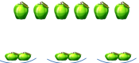  Grouping:  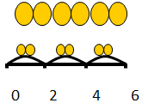  Put these counters into groups of two. How many groups are there? | Recall and use division facts for the 2, 5 and 10 times tables, including recognising odd and even numbers.  Calculate mathematical statements for division within the multiplication tables and write them using the division (÷) and equals (=) sign.  Solve problems involving division using materials, arrays, repeated addition, mental methods and division facts, including problems in contexts.  Arrays:  Show that the multiplication of two numbers can be done in any order (commutative) and division of one number by another cannot. | Use the multiplication tables they know to write and solve division calculations (with and without remainders) including for 2-digit numbers by 1-digit numbers, using mental and progressing to formal written methods.  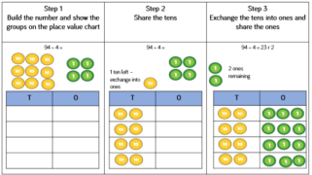  Solve problems, including missing number problems, involving multiplication and division, including positive integer scaling problems and correspondence problems in which n objects are connected to m objectives.  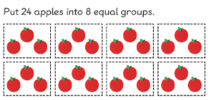 | Recall and use multiplication and division facts for multiplication tables up to 12 × 12.  Count in multiples of 6, 7, 9, 25 and 1000.  Use place value, known and derived facts to multiply and divide mentally, including dividing by 1.  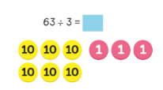  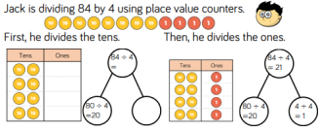 | Divide numbers mentally, drawing upon known facts.  Divide numbers up to 4 digits by a one digit number using the formal written method of short division and interpret remainders appropriately for the context.  3642 ÷ 3 =  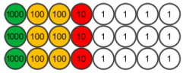  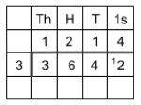  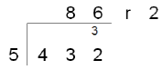  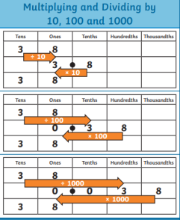  Divide whole numbers and those involving decimals by 10, 100 and 1,000. | Divide numbers up to 4 digits by a 2-digit whole number using the formal written method of long division.  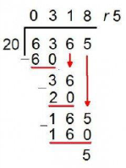  Interpret remainders as whole number remainders, fractions, or by rounding as appropriate for the context.  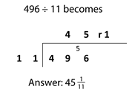  Divide numbers up to 4 digits by a 2-digit number using the formal written method of short division, interpreting remainders according to the context.  Use factor pairs to support division of up to 4 digits by a 2-digit number.  9,840 ÷24 =  Factors of 24 are 12 and 2.  9,840 ÷2 =4,920  4,920 ÷12 = 410  Perform mental calculations, including with mixed operations and large numbers.  Use their knowledge of the order of operations to carry out calculations involving the four operations.  Solve problems involving addition, subtraction, multiplication and division.  Use estimation to check answers to calculations and determine in the context of a problem, an appropriate degree of accuracy.
Times Tables |  |  | Recall and use multiplication and division facts for the 2, 5 and 10 times tables. | Recall and use multiplication and division facts for the 3, 4 and 8 multiplication tables. | Recall and use multiplication and division facts for multiplication tables up to 12 × 12. | No additional requirements – facts to 12 x 12 should be fully secured. | No additional requirements – facts to 12 x 12 should be fully secured.
Fractions | Solve problems, including doubling, halving and sharing  Half of 6 | Recognise, find and name a half as one of two equal parts of an object, shape or quantity.  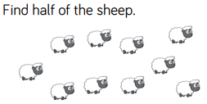  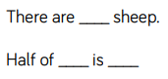  Recognise, find and name a quarter as one of four equal parts of an object, shape or quantity.  Compare, describe and solve practical  problems for: lengths and heights (for example, long/short, longer/shorter,  tall/short, double/half)  Which straw is the tallest?  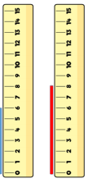  Compare, describe and solve practical problems for: mass/weight [for example, heavy/light, heavier than, lighter than]; capacity and volume [for example, full/empty, more than, less than, half, half full, quarter].  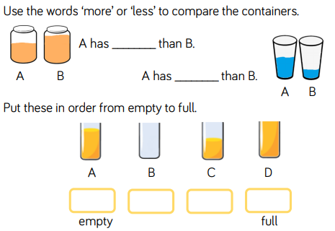 | Recognise, find, name and write fractions 1/3, ¼ , 2/4 and ¾ of a length, shape, set of objects or quantity.  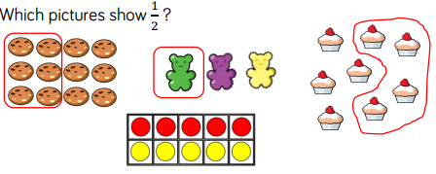  Write simple fractions for example, ½ of 6 = 3 and recognise the equivalence of 2/4 and ½.  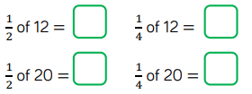 | Count up and down in tenths; recognise that tenths arise from dividing an object into 10 equal parts and in dividing one digit numbers or quantities by 10.  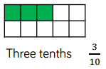  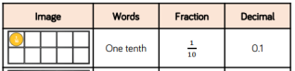  Recognise and use fractions as numbers: unit fractions and non-unit fractions with small denominators.  Recognise, find and write fractions of a discrete set of objects: unit fractions and non-unit fractions with small denominators.  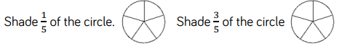  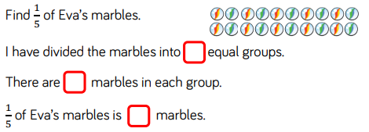  Recognise and show (using diagrams) equivalent fractions with small denominators.  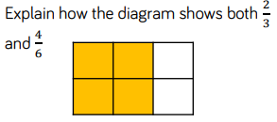  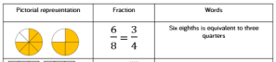  Compare and order unit fractions and fractions with the same denominators.  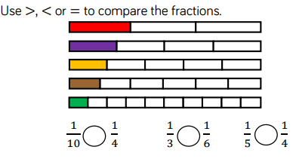  Add and subtract fractions with the same denominator within one whole  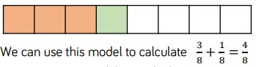  [for example,⁵⁄₇ + ¹⁄₇ = ⁶⁄₇]  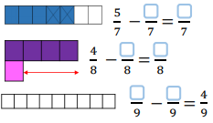  Solve problems that involve all of the above. | 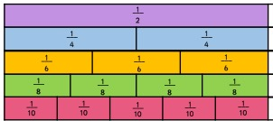  Recognise and show (using diagrams) families of common equivalent fractions.  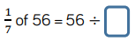  Solve problems involving increasingly harder fractions to calculate quantities, and fractions to divide quantities, including non-unit fractions where the answer is a whole number.  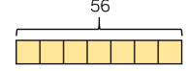  Add and subtract fractions with the same denominator.  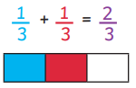  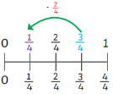  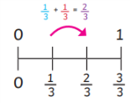  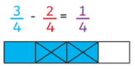 | 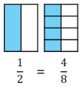  Compare and order fractions whose denominators are multiples of the same number.  Identify, name and write equivalent fractions of a given fraction, represented visually including tenths and hundredths.  Recognise mixed numbers and improper fractions and convert from one form to the other and write mathematical statements >1 as a mixed number [for example ⅖ + ⅘ = ⁶⁄₅ = 1⅕].  Add and subtract fractions with the same denominator and denominators that are multiples of the same number.  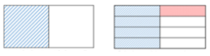  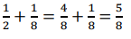  Multiply proper fractions and mixed numbers by whole numbers, supported by materials and diagrams.  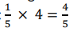  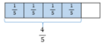  Read and write decimal numbers as fractions [ for example 0.71 = ⁷¹/₁₀₀  Solve problems involving multiplication and division, including scaling by simple fractions and problems involving simple rates. | 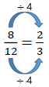  Use common factors to simplify fractions; use common multiples to express fractions in the same denomination.  Compare and order fractions, including fractions > 1  Common denominator to compare $\frac{5}{6}$: and $\frac{3}{4}$.  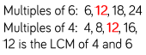  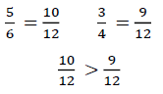  Common numerator to compare:  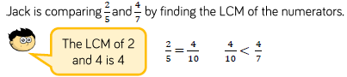  Generate and describe linear number sequences (with fractions).  Add and subtract fractions with different denominations and mixed numbers, using the concept of equivalent fractions.  Multiply simple pairs of proper fractions, writing the answer in its simplest form.  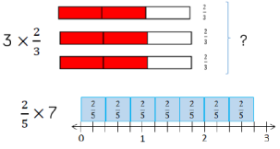  Leading to mathematical calculation of multiplying the numerators together then multiplying the denominators together. [For example $\frac{1}{4}$ x $\frac{1}{2}$ = $\frac{1}{8}$].  Divide proper fractions by whole numbers.  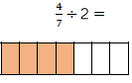  Leading to mathematical calculations of changing the whole to a fraction (2 = $\frac{2}{1}$ ) applying Keep (keep the first fraction the same), Flip (change the ÷ sign to x), Change (change the 2nd fraction around) method then multiplying numerators and denominators. For example $\frac{1}{3}$ ÷ 2 becomes $\frac{1}{3}$ x $\frac{1}{2}$ = $\frac{1}{6}$  Associate a fraction with division and calculate decimal fraction equivalents [for example, 0.375] for a simple fraction [for example $\frac{3}{8}$]  Recall and use equivalences between simple fractions, decimals and percentages, including in different contexts.  i.e. 20% = 0.20 = $\frac{1}{5}$  25% = 0.25 = ¼
Decimals |  | Recognise and know the value of different denominations of coins and notes.  Use < = > to compare the amounts:  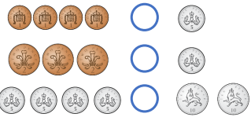 | Recognise and use symbols for pounds (£) and pence (p); combine amounts to make a particular value. | 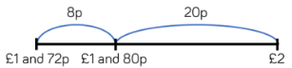  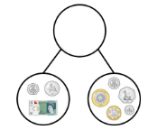  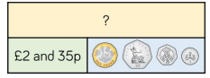  Add and subtract amounts of money to give change, using both £ and p in practical contexts. | Count up and down in hundredths; recognise that hundredths arise when dividing an object by one hundred and dividing tenths by ten.  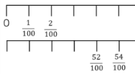  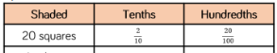  Recognise and write decimal equivalents of any number of tenths or hundredths.  Find the effect of dividing a one or two digit number by 10 or 100, identifying the value of the digits in the answer as ones, tenths and hundredths.  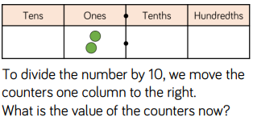  Solve simple measure and money problems involving fractions and decimals to two decimal places.  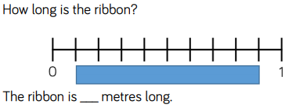  Convert between different units of measure [for example, kilometre to metre].  Compare numbers with the same number of decimal places up to two decimal places.  Round decimals with one decimal place to the nearest whole number.  Recognise and write decimal equivalents to ¼, ½ and ¾.  Find the effect of dividing a one or two digit number by 10 or 100, identifying the value of the digits in the answer as ones, tenths and hundredths. | Read, write, order and compare numbers with up to three decimal places.  Recognise and use thousandths and relate them to tenths, hundredths and decimal equivalents.  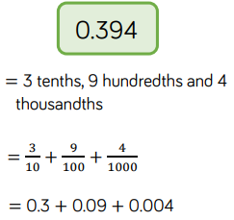  Round decimals with two decimal places to the nearest whole number and to one decimal place.  Solve problems involving number up to three decimal places.  Recognise the per cent symbol (%) and understand that per cent relates to ‘number of parts per hundred’, and write percentages as a fraction with denominator 100, and as a decimal.  Solve problems which require knowing percentage and decimal equivalents of ½, ¼, ⅕, ⅖, ⅘ and those fractions with a denominator of a multiple of 10 or 25.  Multiply and divide whole numbers and those involving decimals by 10, 100 and 1000.  Use all four operations to solve problems involving measure [for example, length, mass, volume, money] using decimal notation, including scaling. | Identify the value of each digit in numbers given to three decimal places and multiply numbers by 10, 100 and 1000 giving answers up to 3 decimal places (dp).  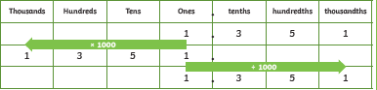  Multiply one digit numbers with up to 2dp by whole numbers.  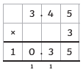  Use written division methods in cases where the answer has up to two decimal places.  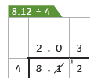  Solve problems which require answers to be rounded to specified degrees of accuracy.  Solve problems involving the calculation of and the use of percentages for comparison. Percentages.  For example 15% of 360 = 54  10% of 360 = 36  5% of 360 = 18  36 + 18 = 54  Recall and use equivalences between simple FDP including in different contexts.
Measures | Use everyday language to talk about size, weight, capacity, position, distance, time and money to compare quantities and objects and to solve problems. | Measure and begin to record lengths and heights.  Compare, describe and solve practical problems for: lengths and heights (for example, long/short, longer/shorter, tall/short, double/half).  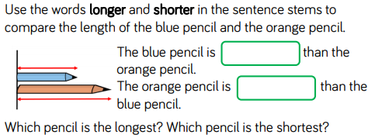  Measure and begin to record mass/weight, capacity and volume.  Compare, describe and solve practical problems for mass/weight: [for example, heavy/light, heavier than, lighter than]; capacity and volume [for example, full/empty, more than, less than, half, half full, quarter].  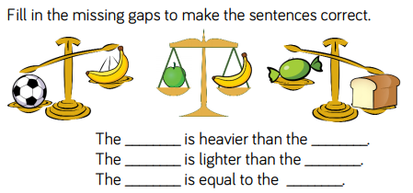  Recognise and know the value of different denominations of coins and notes.  Sequence events in chronological order using language [for example, before and after, next, first, today, yesterday, tomorrow, morning, afternoon and evening.  Recognise and use language relating to dates, including days of the week, weeks, months and years.  Tell the time to the hour and half past the hour and draw the hands on a clock face to show these times.  Compare, describe and solve practical problems for time [for example, quicker, slower, earlier, later].  Tommy is drinking a bottle of orange juice. Match the words to the bottles to order them:  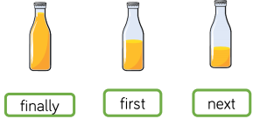  Measure and begin to record time (hours, minutes, seconds). | Recognise and use symbols for pounds (£) and pence (p); combine amounts to make a particular value.  Find different combinations of coins that equal the same amounts of money.  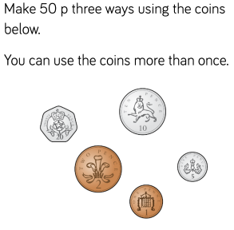  Solve simple problems in a practical context involving addition and subtraction of money of the same unit, including giving change.  Choose and use appropriate standard units to estimate and measure length/height in any direction (m/cm); mass (kg/g); temperature °C); capacity (litres/ml) to the nearest appropriate unit, using rulers, scales, thermometers and measuring vessels.  Compare and order lengths, mass, volume / capacity and record the results using >, < and =.  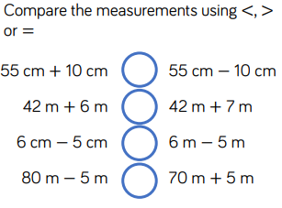  Tell and write the time to five minutes, including quarter past/to the hour and draw the hands on a clock face to show these times.  Know the number of minutes in an hour and the number of hours in a day.  Compare and sequence intervals of time.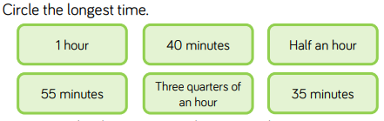 | Add and subtract amounts of money to give change, using both £ and p in practical contexts.  Measure, compare, add and subtract: lengths (m/cm/mm); mass (kg/g); volume/capacity l/ml).  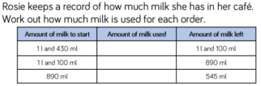  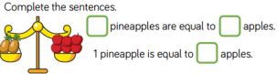  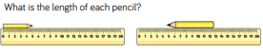  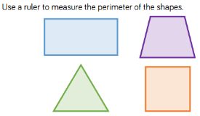  Measure the perimeter of simple 2D shapes.  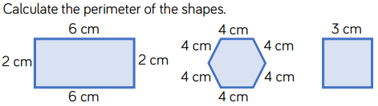  Tell and write the time from an analogue clock, including using Roman numerals from I to XII and 12 hour and 24 hour clocks.  Estimate and read time with increasing accuracy to the nearest minute.  Record and compare time in terms of seconds, minutes and hours.  Use vocabulary such as o’clock, a.m./p.m., morning, afternoon, noon and midnight.  Know the number of seconds in a minute and the number of days in each month, year and leap year.  Compare durations of events [for example to calculate the time taken by particular events or tasks].  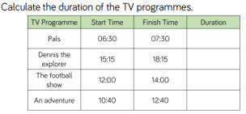 | Estimate, compare and calculate different measures, including money in pounds and pence.  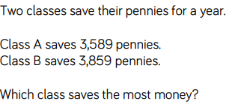  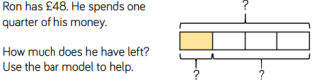  Solve simple measure and money problems involving fractions and decimals to two decimal places.  Find the area of rectilinear shapes by counting squares.  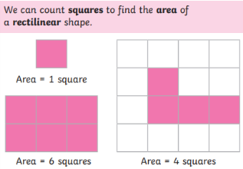  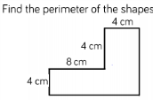  Measure and calculate the perimeter of a rectilinear figure (including squares) in centimetres and metres.  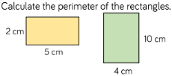  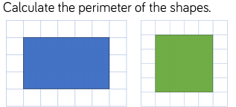  Convert between different units of measure [for example, kilometre to metre].  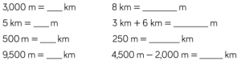  Read, write and convert time between analogue and digital 12 and 24 hour clocks.  Solve problems involving converting from hours to minutes; minutes to seconds; years to months; weeks to days. | 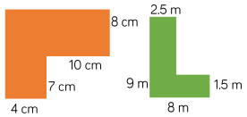  Measure and calculate the perimeter of composite rectilinear shapes in centimetres and metres.  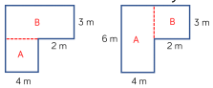  Calculate and compare the area of rectangles (including squares), including using standard units, square centimetres (cm²) and square metres (m²), and estimate the area of irregular shapes.  Convert between different units of metric measure [for example, km and m; cm and m; cm and mm; g and kg; l and ml].  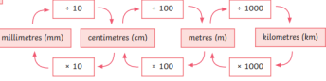  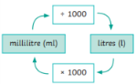  Understand and use approximate equivalences between metric units and common imperial units such as inches, pounds and pints.  Solve problems involving converting between units of time.  Estimate volume [for example using  1cm3 blocks to build cuboids (including cubes)] and capacity [for example, using water].  Use all four operations to solve problems involving measure. | Solve problems involving the calculation and conversion of units of measure, using decimal notation up to three decimal places where appropriate.  Use, read, write and convert between standard units, converting measurements of length, mass, volume and time from a smaller unit of measure to a larger unit, and vice versa, using decimal notation to up to 3dp.  Convert between miles and kilometres.  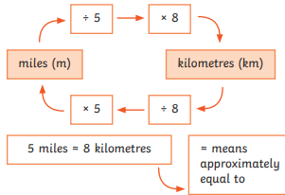  Recognise that shapes with the same areas can have different perimeters and vice versa.  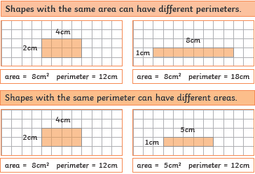  Recognise when it is possible to use formulae for area and volume of shapes:  Length x width = area becomes  l x w = a²  Length x width x height = volume becomes l x w x h = v³  Calculate the area of parallelograms and triangles.  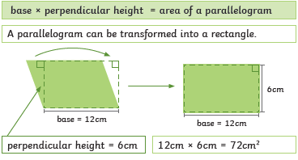  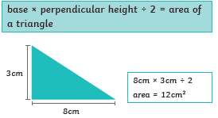  Calculate, estimate and compare volume of cubes and cuboids using standard units, including cm3, m3 and extending to other units (mm3, km3).
Geometry | Explore characteristics of everyday objects and shapes and use mathematical language to describe them.  Recognise, create and describe patterns. | Recognise and name  common 2 D shapes,  including: (e.g. rectangles  (including squares), circles and triangles).  Which is the odd one out in each group?  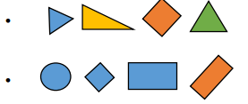  Recognise and name  common 3 D shapes,  including: (e.g. cuboids  (including cubes), pyramids and spheres).  Describe position, direction and movement, including whole, half, quarter and three quarter turns.  Use a grid to move a bot to different places using the words ‘left’, ‘right’, ‘forwards’, ‘backwards’. Include turns as well.  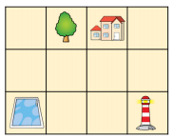 | Identify and describe the properties of 2 D shapes, including the number of sides and line symmetry in a vertical line.  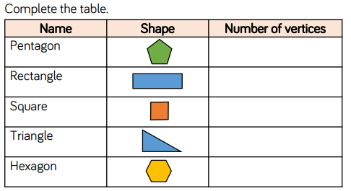  Identify and describe the properties of 3 D shapes, including the number of edges, vertices and faces.  Identify 2 D shapes on the surface of 3 D shapes, [for example, a circle on a cylinder and a triangle on a pyramid].  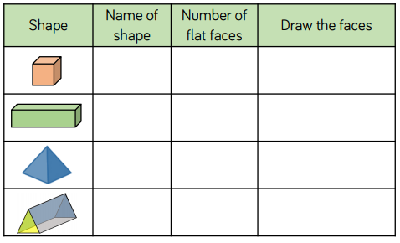  Compare and sort common 2 D and 3 D shapes and everyday objects.  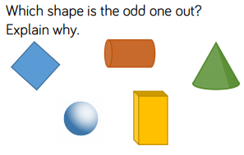  Use mathematical vocabulary to describe position, direction and movement including movement in a straight line and distinguishing between rotation as a turn and in terms of right angles for quarter, half and three quarter turns (clockwise and anti-clockwise).  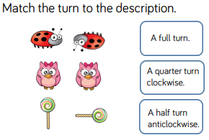  Order and arrange combinations of mathematical objects in patterns and sequences.  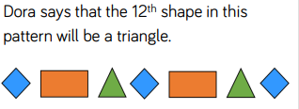 | Recognise angles as a property of shape or a description of a turn.  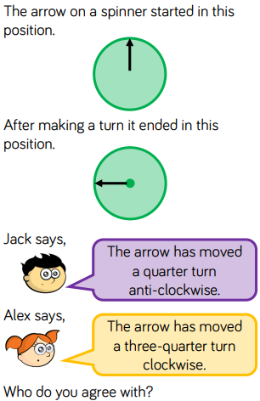  Identify right angles, recognise that two right angles make a half turn, three make three quarters of a turn and four a complete turn; identify whether angles are greater than or less than a right angle.  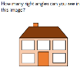  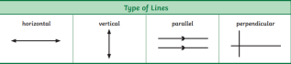  Identify horizontal and vertical lines and pairs of perpendicular and parallel lines.  Draw 2 D shapes and make 3 D shapes using modelling materials.  Recognise 3 D shapes in different orientations and describe them.  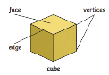  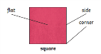 | Identify acute and obtuse angles and compare and order angles up to two right angles by size.  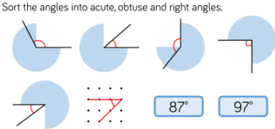  Compare and classify geometric shapes, including quadrilaterals and triangles, based on their properties and sizes.  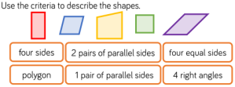  Identify lines of symmetry in 2D shapes presented in different orientations.  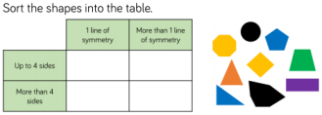  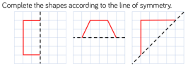  Complete a simple symmetric figure with respect to a specific line of symmetry.  Describe positions on a 2D grid as coordinates in the first quadrant.  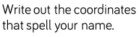  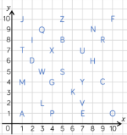  Plot specified points and draw sides to complete a given polygon.  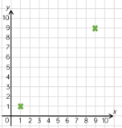  i.e. plot 2 more points to make a square.  Describe movements between positions as translations of a given unit to the left/ right and up/ down. | Identify 3D shapes, including cubes and other cuboids, from 2D representations.  Use the properties of rectangles to deduce related facts and find missing lengths and angles.  Distinguish between regular and irregular polygons based on reasoning about equal sides and angles.  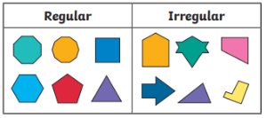  Know angles are measured in degrees; estimate and compare acute, obtuse and reflex angles.  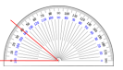  Draw given angles, and measure them in degrees.  Identify angles at a point and one whole turn (total 360 °), angles at a point on a straight line and ½ a turn (total 180 °) other multiples of 90°.  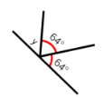  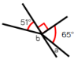  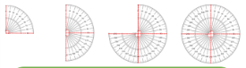  Identify, describe and represent the position of a shape following a reflection or translation, using the appropriate language, and know that the shape has not changed. | Draw 2D shapes using given dimensions and angles.  Compare and classify geometric shapes based on their properties and sizes and find unknown angles in any triangles, quadrilaterals and regular polygons.  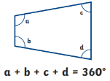  Recognise angles where they meet at a point, are on a straight line, or are vertically opposite, and find missing angles.  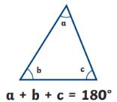  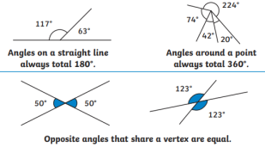  Illustrate and name parts of circles, including radius, diameter and circumference and know that the diameter is twice the radius.  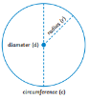  Describe positions on the full coordinate grid (all four quadrants).  Draw and translate simple shapes on the coordinate plane, and reflect them in the axes.
Statistics |  | - | Interpret and construct simple pictograms, tally charts, block diagrams and simple tables.  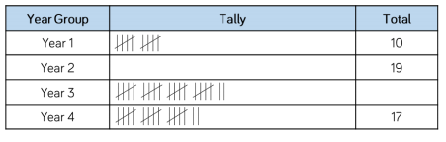  Ask and answer simple questions by counting the number of objects in each category and sorting the categories by quantity.  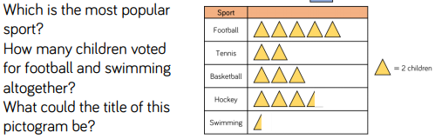  Ask and answer questions about totalling and comparing categorical data.  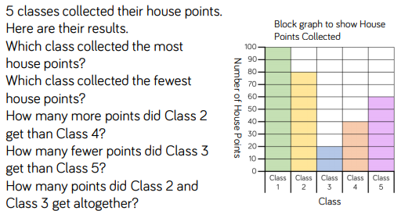 | Interpret and present data using bar charts, pictograms and tables.  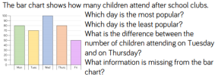  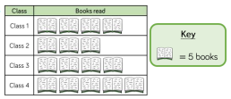  Solve one step and two step questions [for example, ‘How many more?’ and ‘How many fewer?’] using information presented in scaled bar charts and pictograms and tables. | Interpret and present discrete and continuous data using appropriate graphical methods, including bar charts and time graphs.  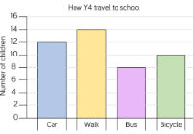  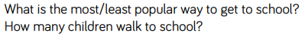  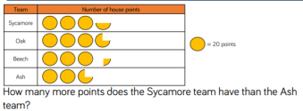  Solve comparison, sum and difference problems using information presented in bar charts, pictograms, tables and other graphs.  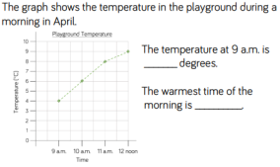 | Solve comparison, sum and difference problems using information presented in a line graph.  Complete, read and interpret information in tables including timetables. | Interpret and construct pie charts and line graphs and use these to solve problems.  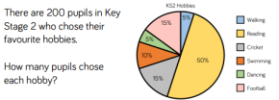  Calculate the mean as an average.  For example, here are the scores of 5 netball matches:  3, 6, 4, 4, 3  To find the mean average, add all the scores up (20) and divide by the number of scores (5). 20 ÷ 5 = 4  The mean average is 4.
Additional areas of study |  | - | - | - | - | - | Algebra:  Use simple formulae.  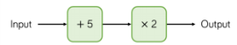  Generate and describe linear number sequences.  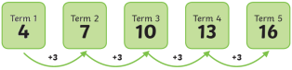  Express missing number problems algebraically.  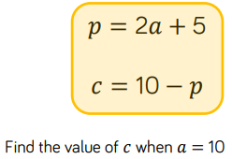  Find pairs of numbers that satisfy an equation with two unknowns.  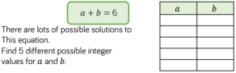  Enumerate possibilities of combinations of two variables.  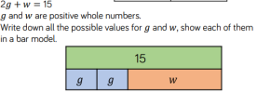  Ratio:  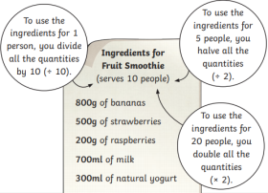  Solve problems involving the relative sizes of two quantities where missing values can be found by using integer multiplication and division facts.  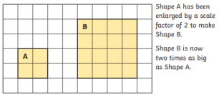  Solve problems involving similar shapes where the scale factor is known or can be found.  Solve problems involving unequal sharing and grouping using knowledge of fractions and multiples.

