School Impact Reviews:
School Backwell Juniors
Term 1
INTENT: Children will have the chance to develop a wide range of skills, many fundamental to children’s development, and others more sport focused. Curriculum and lesson design that is fully inclusive and accessible means that all children can feel, and ultimately, be successful. The intent is that children will learn across key areas, skills, knowledge, understanding and application. Where possible, it will be our intent to give children experiences to support this learning progression. Building on the fundamentals of movement which are central to the delivery, as is using the physical literacy model to support children for each stage of learning and progressing on from the EYFS framework.
The overarching intent in school will be to meet the four aims of the national curriculum in an exciting and engaging way that inspires all children. The aims of the national curriculum for physical education are to ensure that all pupils:
• develop competence to excel in a broad range of physical activities
• are physically active for sustained periods of time
• engage in competitive sports and activities
• lead healthy, active lives

IMPLEMENTATION: Our intent is to deliver these outcomes both in schools and their communities by offering sport, physical activity and personal development experiences. Delivering in school time, extra-curricular time, enrichment time and during school holidays to support everyone in being physically and mentally active. All children should have an opportunity to meet the requirements of the national curriculum for physical education, plus national drives for increased activity and opportunity, and to find an activity or aspect of being physically active that they enjoy and engage with in the future.
The PE focus in term 1:
LKS2 – Invasion Games - General overview of invasion games, looking to select and apply the correct skills in the right situation. Understand the principles of teamwork and attacking and defending. Will look to further develop game-based skills with a focus on hand-eye coordination skills and applying them to different outcomes. Year 3 have made a positive start to P.E showing lots of understanding and competencies throughout. A clear understanding of the expectations set down at West leigh and carrying on up to the Junior school seems to have helped this. A few were finding it difficult with the change in length of P.E but have persevered well in challenging weather conditions. Year 4 have found it tricky to settle into P.E lessons at the start of this year, concentration levels and basic team skills have been challenging for them across lessons. Children have shown improvements and are working towards being at the expected levels for a lesson. Lots of communication and goal setting with the teachers has helped to push children to start to make the right choices.
UKS2 - Invasion Games - Improve skills of sending and receiving in different situations. To evaluate others and own performance and suggest ways to improve. To be able to improve individual and team performances. Develop the group skills of game-based activity and how individual skills can be used to improve team performance. Year 5 have started the year the best in terms of P.E within the school. Demonstrating great understanding and teamwork across the term. The only area for improvement with this year group will be around competition and winning / losing in a sports person like manner. This has always been a challenge and we are working towards being better sports people in our lessons through striking and fielding in T2. Year 6 have demonstrated the competency levels and understanding we would be expecting but there has beena lack of behaviour across certain individuals in lessons and in certain areas down to basic listening / respect. We are trying to provide the children with a learning without limits environment and pushing them to challenge themselves in different ways but this is quite tricky in the current circumstances. To solve this we may have to go back to a more autocratic teaching approach until they can demonstrate the ability to lead their own learning effectively.
IMPACT:
Data:
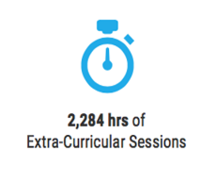

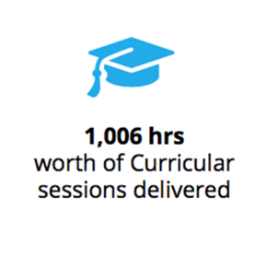
40 Hours of Curricular PE
18 hours of Sport Active

100% of school in PE each week
92% capacity in sports clubs
100% of children Assessed

PE Assessment Data
 | Emergent | Expected | Exceeding
Year 3 | 7.5% | 47.5% | 45%
Year 4 | 11.5% | 44% | 44.5%
Year 5 | 2% | 43% | 55%
Year 6 | 19.5% | 31.5% | 49%

Summary: The assessment data for term 1 is very positive and has shown that the school has been able to continue to achieve highly. We have seen a high number of children achieving above the expected levels.
So far we have seen strong achievement in all year groups and as shown above the achievement is higher as we move through the school. We can see that this term in particular reflective learning has been a positive, there are quite high levels of emerging children in the engagement and discipline areas in year 4 mostly that we are looking to improve upon in term 2. Year 5 have seen the highest levels of achievement so far this year with large numbers of children above the expected levels.
Regarding extra-curricular clubs, we have been really impressed with the achievement, engagement, and behaviour by all who have attended, we have been really impressed with the numbers for our girls football clubs and have also been able to support the school in taking teams to local competitions this term as well.
Action Points:
- To reduce the children in the emergent levels
- Support the improvement of year 6 with engagement and discipline particularly

Class Assessments
3W  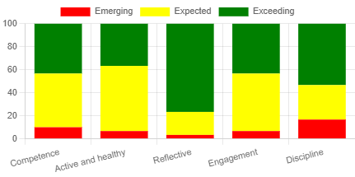 | 3AJ  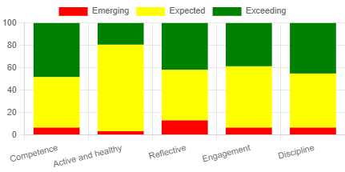
4W  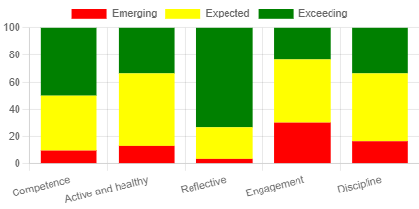 | 4J  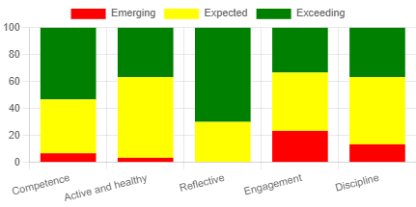
5Y  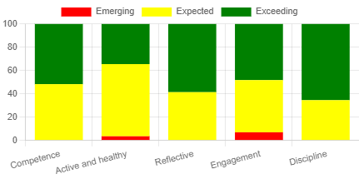 | 5BH  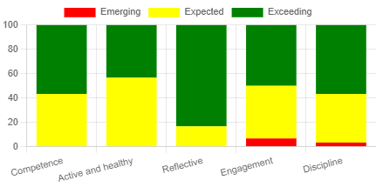
6M  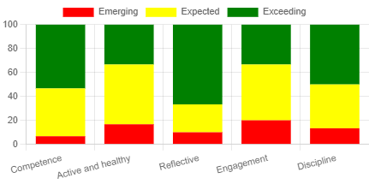 | 6B  

